  - How to Export the Rylson8 Maintenance Strategy Template
To obtain a blank upload sheet from Rylson8 you will need to be in advanced mode. The following provide detailed instructions on how to do complete this:
  - On the top ribbon, Go to the ‘Options’ tab
  - On the next lower ribbon Click on ‘Preferences’ – a ‘User Preferences’ window will open.
  - Under ‘Last Accessibility level’ if ‘Basic’ is selected (by default) change this using the drop down box to ‘Advanced’ and click ‘Save’.

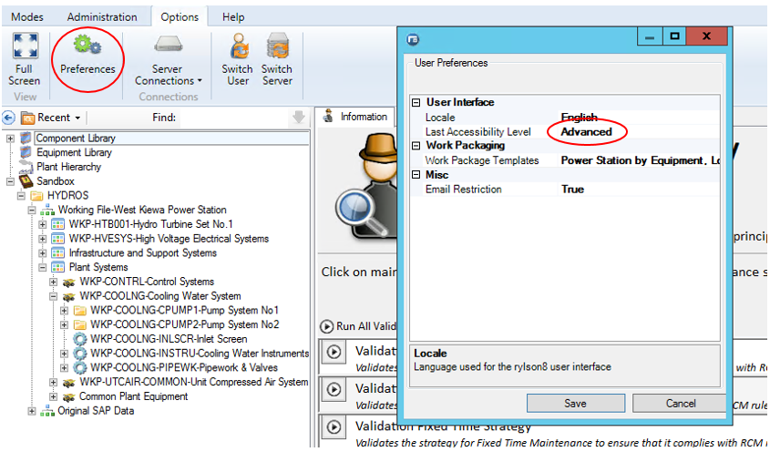

To download the template select the “Modes” tab from the top ribbon and then select the “Maintenance Strategy” tab. In the hierarchy left click an “Equipment” or “Maintainable Item”. Select the “Equipment Strategies” tab if at an “Equipment” node or the “Strategies” tab if at a “Maintainable Item” node. On the far right of the page select “Export”.

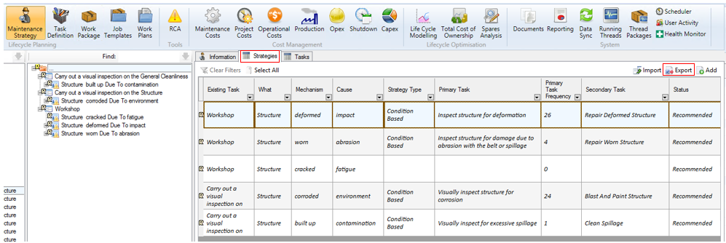

A pop up screen will appear and click on “Create empty import template (no data)” and then click “Next”.

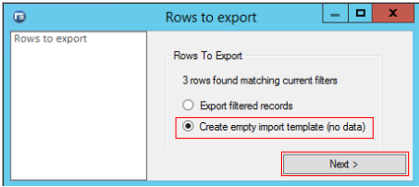
Another pop-up windows appears. Click on “Select All” and then click “Next”.

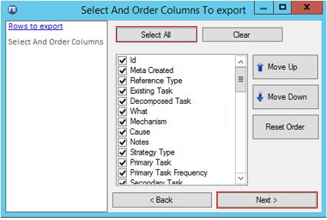
Click on “Excel 2007” and then click “Next”.
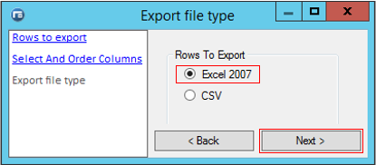
The default setting for the file location is the Microsoft Azure desktop. An alternate location may be selected to store the file by selecting “Browse”. Select the file location as with Windows Explorer. Select .xlsx file type and name for file. This will become the new default location for the files until you log out or change the location.
The file may be opened after export by ticking the box. The click “Next”.
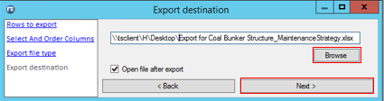
A summary report shows the selections made during the export process. At any point “Back” can be clicked on to change the previous selections. Select “Finish” to complete the export process.
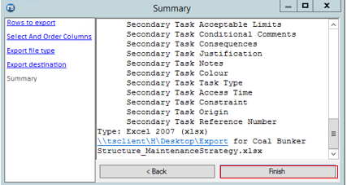
  - Preparation of the Template for Upload
Columns can be organised to suit individual preferences; however, a suggested order going from left to right; Maintainable Item, Existing task, Decomposed Task, What, Mechanism, Cause, Notes, Strategy Type, Primary Task, Primary Task Frequency, Secondary Task, Operational Units, Time Units, and Operational Conversion. Other fields are available and may be included, but are not required for the Maintenance strategy upload sheet.
The columns on the existing strategy must be aligned to the fields in the Rylson8 template sheet. It is much easier to populate all the required fields in the spread sheet prior to uploading into Rylson8. The key fields on the existing strategy that must be identified are:
- The description of the existing strategy tasks.
- The primary and secondary task frequency and units. Frequency and units are separate fields and may be in the same column on the CMMS export. These will have to be separated for the Rylson8 template. The units are either operational or time based one must be selected for each task entered. They are case sensitive.
  - Operational Units are; Cycles, Meters, Operational Hours, or Tonnes,
  - Time Units are; Hours, Days, Weeks, Years. Please convert months into the equivalent number of weeks.
- The secondary task frequency and units. These may be in the same column and will have to be separated for the Rylson8 template.
- Strategy type must align with Rylson8 code selections and must be populated for all entries. They are case sensitive and are as follows:
  - Condition Based
  - Fault Find Interval
  - Fixed Time
  - Run Until failure
- Operational Conversion should be set to 1 and must be populated for all entries.
What, Mechanism and Cause are not required to be populated for the upload; however, they will assist in the development of the maintenance strategies. These three fields address the Failure. The ‘What’ refers to the component or maintainable item. The Mechanism is how the failure occurs and the Cause is why the failure occurs. It is unlikely these are available from the CMMS download. If they are to be imported they must align with the approved AGL Mechanism and Cause List. This is available on the MSD Share Point page.

  - Rylson8 Upload Process – Create New Records
The completed template is uploaded into Rylson8 utilising the following process;
Select the “Mode” tab at the top ribbon in Rylson8, then select the “Maintenance Strategy” tab. On the far right of the page select “Import”.

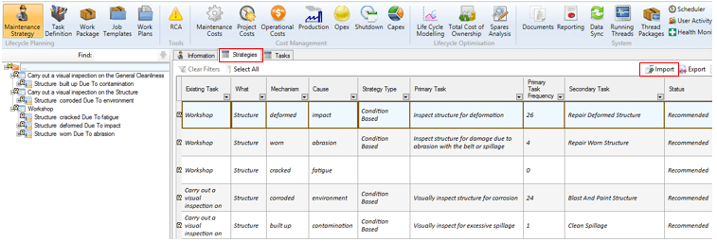
Click on “Browse” and navigate to the file location where the template was previously stored from the process above. Once the file is located select “Open”. When the file loads click “Next”.

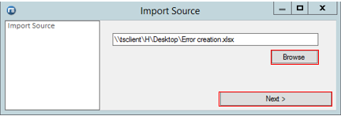

A new pop up window will appear, tick on the box “Create New Records”. Then click “Next”.

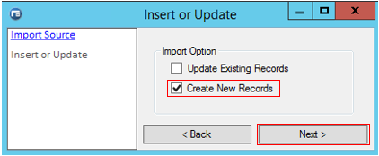
A new pop up window will appear to map column names that may be different from those in the template. When completed mapping all the columns click “Next”.

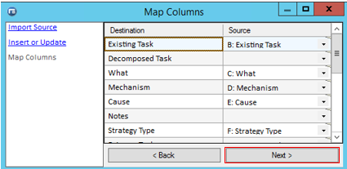

A summary window then appears, click “Finish”.
The file is now imported into Rylson8.

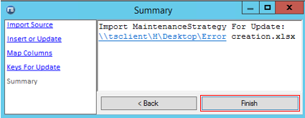

Any errors will prevent the file from saving and must be corrected. Errors have a red exclamation mark and if hovered over provide details of the error. There is a tick box at the bottom of the screen that displays only the rows with errors.
If there are a substantial amount of errors review them and then click “Revert”. Correct the errors in the template and then follow the upload process again.
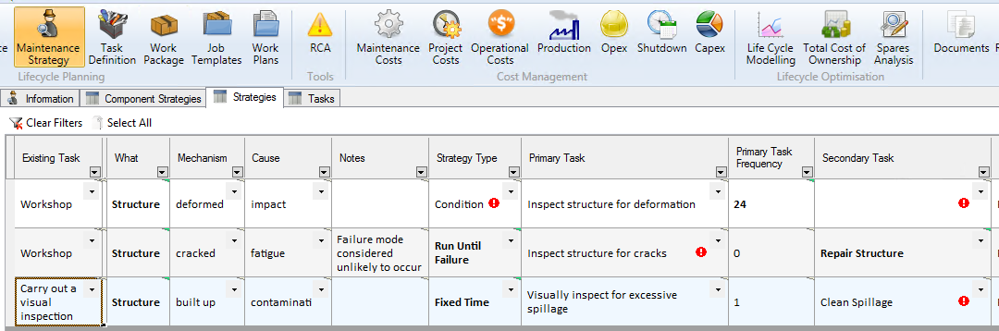
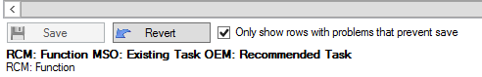
  - Rylson8 Upload Process – Update Existing Records
The completed template is uploaded into Rylson8 utilising the following process;
Select the “Mode” tab at the top ribbon in Rylson8, then select the “Maintenance Strategy” tab. On the far right of the page select “Import”.
Click on “Browse” and navigate to the file location where the template was previously stored from the process above. Once the file is located select “Open”. When the file loads click “Next”.

A new pop up window will appear, tick on the box “Update Existing Records”. Then click “Next”.

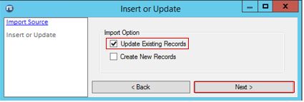

A new pop up window will appear to map column names that may be different from those in the template. When completed mapping all the columns click “Next”.

A new pop up window will appear which requires alignment of the fields in the upload template with those already populated in Rylson8. It is advisable to select a field that has an individual correlation for each row. The preferable selection is the “Id” field. Any field or multiple fields may be selected; however, if it is not unique for each row it is likely that errors will occur where Rylson8 is unable to match the fields. When completed selecting a “Key” click “Next”.

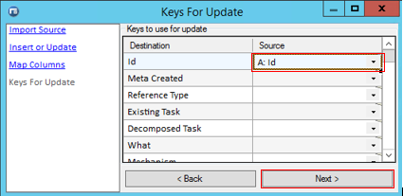
A summary window then appears, click “Finish”.

The file is now imported into Rylson8.

Any errors will prevent the file from saving and must be corrected. Errors have a red exclamation mark and if hovered over provide details of the error. There is a tick box at the bottom of the screen that displays only the rows with errors.
If there are a substantial amount of errors review them and then click “Revert”. Correct the errors in the template and then follow the upload process again.

